Documentation on changes made to Hockshi by juniorhoza56@gmail.com

This document will try to outline all the changes made to the hockshi project .

Documentation on changes made to Hockshi by juniorhoza56@gmail.com
Table of content
1. File Structure changes
Controllers Directory
adminController.js
BookController.js
IndexController.js
OrdersController.js
Models Directory
Migration directory
Seeders Directory
Containers Directory
Config Directory
Middleware Directory
- verifyLogin.js
- verifyBookForm.js
- OTPmiddleware.js
2. CHANGES MADE TO THE FUNCTIONS.JS FILE
Const connect
Const generateAndSendOTP
Const Md5Rand
Const checkUploadDir
Const checkFileExtension
3. ENV CONFIGURATION
4. HOW TO RUN THE APPLICATION

File Structure changes
in an attempt to follow the requirements stipulated in the SRS document which stipulated that the project should be built using an MVC architecture, i added a
- controllers directory
- models directory
- Migrations directory
- Seeders directory
- Containers directory
- Config directory
- Middleware directory

Controllers Directory
├── views │
├── adminController.js
├── BookController.js
├── indexController.js
├── OrdersController.js

This directory contains 3 main controllers which are the adminController.js, the BookController.js and the indexController.js

adminController.js
The adminController.js file contains handler functions such as

-const login=(req,res):
The role of this function is to render admin_login page that contains a form for the admin to login
const login=(req,res,next)=>{
//the login function renders the login page that will request the email and password of the users who wishes to login
res.render("pages/admin_login",{
msg:false,
host:process.env.HOST
})
}

- Const formSubmit = async(req,res)
The form submit function is an asynchronous function that verifies the inputs entered by the user and if they are correct it redirect the user to the OTP page

const formSubmit= async(req,res,next)=>{
/*
the formsubmit funtion is an async function that is used to verify if the user who wants to login exists , the logic behind it's functioning is as follows
1. It extracts the email from the request body.
2. It then tries to find a user with the same email in the database.
3.If no user is found, it renders the "pages/admin_login" template with an error message.
4. If a user is found, it checks if the provided password matches the hashed password stored in the database.
5. If the password matches, it generates and sends an OTP (One-Time Password) for the user.
6. It then renders the "pages/otpVerification" template with the user's ID, email, and host.
7. If the password does not match, it renders the "pages/admin_login" template with an error message.
8.If an error occurs during the process, it logs the error to the console.
The function uses await to handle asynchronous operations and bcrypt.compare to compare the provided password with the hashed password. The powerUSer.findOne method is used to find a user in the database. The res.render method is used to render templates. The process.env.HOST variable is used to get the host of the application.

*/
const email=req.body.email
try {
const user = await powerUSer.findOne({
where: {
email: email,
}
});
if(!user){

res.render("pages/admin_login",{
csrfToken:req.csrfToken(),
msg:"please check your email and password again",
host:process.env.HOST
})
}
else{
if( await bcrypt.compare(req.body.password,user.password)){
user_email=email
userId=user.id
authUser=user.dataValues
generateAndSendOTP(user.id,user_email)
I res.render(`pages/otpVerification`,{
userId:userId,
email:user_email,
msg:false,
host:process.env.HOST
})
}
else{
res.render("pages/admin_login",{
csrfToken: req.csrfToken(),
msg:"please check your email and password again",
host:process.env.HOST
})
}
}
}
catch(e){
console.error('Error:', e);

}

}

- Const verifyOTP=(async(req,res))
As said earlier, when the user enters his correct login informations , an otp code will be generated and sent to his email. The verifyOTP function checks if the otp entered by the user in the otp form matches the otp generated and sent to his Emai

const verifyOTP=(async(req,res,next)=>{
/**
* The verifyOTP function is an asynchronous function that verifies a one-time password (OTP) sent by a user. It interacts with a database to check the OTP, handles validation errors, and manages user session data. If the OTP is valid and not expired, it sets up the user session and redirects to the dashboard.
*
*
*/

// Extract userId and OTP from the request body
const{userId,OTP}=req.body

// otpModel.findOne searches for an OTP record with the matching userId and OTP.
const otpRecord= await otpModel.findOne({
where:{
powerUserId:userId,
otp:OTP
}
})

/**
* validationResult(req) checks for any validation errors in the request.
If there are errors, render the otpVerification page with an error message.
*/
const errors=validationResult(req)
if(!errors.isEmpty()){
const {msg}=errors.array()[0]
res.render(`pages/otpVerification`,{
userId:userId,
email:user_email,
msg:msg,

})
return //stops futher execution if there is an error

}

/**
* If no OTP record is found, render the otpVerification page with an "invalid OTP record" message.
*/
if(!otpRecord){
authUser="";

res.render(`pages/otpVerification`,{
userId:userId,
email:user_email,
msg:"invalid OTP record",

})
}
/**
* If the OTP record is found but expired, render the otpVerification page with an "OTP expired" message.
*/
else if(otpRecord.expiration_time < new Date()){
authUser="";

res.render(`pages/otpVerification`,{
userId:userId,
email:user_email,

msg:"OTP expired",

})
}else{
/**
* If the OTP is valid and not expired:

Set up the user session with req.session.user.
Destroy the OTP record from the database to prevent reuse.
Redirect the user to the dashboard.
*/
req.session.user={
email:authUser.email,
role:authUser.role
}
await otpModel.destroy({
where:{
powerUserId:userId
}
})
res.redirect(`${process.env.HOST}/admin/dashboard`)
}
})
l

- Const dashboard=async(req,res)
This is the final step of the authentication flow, if the user entered the correct otp code , he will be redirected to his dashboard and it will be handled by this function , before rendering the page , it will fetch all the books present in our database

const dashboard=async(req,res)=>{
/*
Inside the dashboard handeler function, it first checks if a query parameter named msg exists in the request object. If it does, it assigns false to the msg variable; otherwise, it assigns the value of msg from the request query.

Then, it uses the await keyword to asynchronously fetch all books from the bookModel along with their associated genreModel and inventoryModel using the findAll method.

Finally, it renders a view template named "pages/dashboard" and passes the fetched books, msg, and the value of process.env.HOST as data to the template.
*/
const msg=req.query.msg?false:req.query.msg;

const books= await bookModel.findAll({
include:[
{model:genreModel},
{model:inventoryModel}

],

})
// res.send(user)
res.render("pages/dashboard",{
books:books,
msg:msg,
host:process.env.HOST

})
}

- Const logout =(req,res)
This route is used to logout the user , it first checks if the user is signed in by inspecting the req.session.user if the user is signed in , the program will delete the user attribute from the session object thus logging the user out after deleting this attribute, the user will be redirected to the login page

const logout=(req,res)=>{
/*
the logout function is used to logout signed in users.

It checks if the user is signed in by looking for the user property in the req.session object. If the user is not signed in, it responds with a status code of 404 and a message saying "user not signed in". If the user is signed in, it deletes the user property from the req.session object and redirects the user to the root URL of the admin section of the application (${process.env.HOST}/admin/).

*/
if(!req.session.user){
res.status(404).send("user not signed in")

}
else{
delete req.session.user
res.redirect(`${process.env.HOST}/admin/`)

}
}

BookController.js

The bookController.js contains mainly CRUD handler functions , the handle operation like create , read on the user table

- Const GetinsertBook= async (req,res)
The role of this function is to render the form that will permit the admin to add a book into the database , for the book to be created, all the values in the form should be filled

const GetinsertBook= async(req,res)=>{

/**
* The purpose of this function is to display a form for inserting a new book, pre-populated with a list of genres to choose from.

Here's what it does:

1. It asynchronously fetch all genres from the genreModel.
2. It then renders a view template named "pages/bookInsert" and passes the fetched genres, the host URL from 3. the environment variables, a msg variable set to false, and a formdata variable set to false.

*/
const genre= await genreModel.findAll()

res.render("pages/bookInsert",{
host:process.env.HOST,
genre:genre,
msg:false,
formdata:false

})
}

- Const CreateBook=async(req,res)

The create book is an asynchronous function which handles handles post requests for the creation of a new book, it checks if there are no errors with the data entered by the user , if there are errors the user will be redirected to the book insertion page with his errors

const CreateBook=async (req,res)=>{

/**
* The create book is an asynchrounous function which handles handles post requests for the creation of a new book
*/

//The function first checks for any validation errors using validationResult(req).

const errors=validationResult(req)

// If there are validation errors, it retrieves all genres from the database and adds an error message if no file (cover image) is uploaded.

if(!errors.isEmpty()){
const genre= await genreModel.findAll()

const error=errors.array()
if(!req.file){
error.push({

type: 'field',
value: '',
msg: 'Cover Image Is Required',
path: 'cover_image_url',
location: 'body'

})
}

res.render("pages/bookInsert",{
host:process.env.HOST,
genre:genre,
msg:error,
formdata:req.body
})

}else{
// If there are no validation errors, it creates a new book using the bookModel, and creates a new inventory using the inventoryModel.
let book= await bookModel.create({
title:req.body.title,
ISBN:req.body.ISBN,
genre:req.body.genre,
author:req.body.author,
description:req.body.description,
cover_image_url:req.file.path,
language:req.body.language,
price:req.body.price,
publication_date:req.body.date

})
inventoryModel.create({
book_id:book.book_id,
quantity_available:req.body.quantity,
location:req.body.location
})

return res.redirect(`${process.env.HOST}/admin/dashboard?msg=item+successfully+added`);
}
// File information is available in req.file
}

- Const updateBook=async (req,res)
Just as the GetinsertBook, this role of this function is to render the page containing the form that will enable the user to update a book

const updateBook=async (req,res)=>{
/**
* Inside the function, it uses the await keyword to asynchronously find a book by its primary key (req.params.id) from the bookModel and includes the associated genreModel and inventoryModel.

It then retrieves all genres from the genreModel using the findAll method.

Finally, it renders a view template named "pages/updateBook" and passes the fetched book, root path from the environment variable process.env.ROOT_PATH, the cover image URL from the book, and the fetched genres as data to the template.
*/
let book= await bookModel.findByPk(req.params.id, {include:[
{model:genreModel},
{model:inventoryModel}

]},)
const genre= await genreModel.findAll()

// res.send(book)
res.render("pages/updateBook",{
book:book,
root_path:process.env.ROOT_PATH,
image:book.cover_image_url,
genre:genre

})

}

- Const saveUpdate=async(req,res)
The saveUpdate function handles updating a book and its associated inventory record. It first retrieves the book and inventory records by the book ID, updates the fields with the new data, deletes the old cover image file if a new file is uploaded, and saves the changes to the database.

const saveUpdate=async(req,res)=>{
/**
* The saveUpdate function handles updating a book and its associated inventory record. It first retrieves the book and inventory records by the book ID, updates the fields with the new data, deletes the old cover image file if a new file is uploaded, and saves the changes to the database.
*/
try{
/**
* The function retrieves the book and inventory records from the database using the primary key (bookId). If the book or inventory records are not found, it returns a 404 error.
*/
const book= await bookModel.findByPk(req.body.bookId)
const inventory=await inventoryModel.findByPk(req.body.bookId)

if(!book || !inventory){
return res.status(404).send("record not found")
}
else{
//The function updates the fields of the book and inventory records with the data from the request body.

book.set({
title :req.body.title,
author : req.body.author,
ISBN :req.body.ISBN,
language : req.body.language,
price :req.body.price,
description :req.body.description,
publication_date:req.body.date,
genre:req.body.genre,
})

inventory.set({
quantity_available : req.body.quantity,
location:req.body.location,
})

if(req.file){
//If a new file is uploaded, the old cover image file is deleted from the file system, and the new file path is set.
const coverImagePath = path.join(process.env.ROOT_PATH, book.cover_image_url);
// Delete the cover image file
fs.unlink(coverImagePath, async (err) => {
if (err) {
return res.status(500).json({ error: 'Error deleting file' });
}
})

book.set({cover_image_url:req.file.path})

}
//The function saves the updated book and inventory records to the database.

await book.save()
await inventory.save()

//After successful update, the user is redirected to the dashboard with a success message.

res.redirect(`${process.env.HOST}/admin/dashboard?msg=item+successfully+updated`);

}

}

catch(e){
console.log("error",e)
res.status(500).send('Server error');

}

}

- Const deleteBook=async (req,res)
This functions is used to delete a book from the database and its cover image from the file system

const deleteBook=async (req,res)=>{

/**
* Deletes a book and its associated cover image from the server and database.
*
* This function performs the following steps:
* 1. Retrieves the book record from the database by its primary key (ID) provided in the request parameters.
* 2. Constructs the path to the cover image file associated with the book.
* 3. Attempts to delete the cover image file from the server's file system.
* 4. If the image deletion is successful, it deletes the book record from the database.
* 5. Redirects the user to the admin dashboard with a success message if the deletion is successful.
* 6. If an error occurs at any step, logs the error and redirects the user to the admin dashboard with an error message.
*
*/
let book= await bookModel.findByPk(req.params.id)
try{
const coverImagePath = path.join(process.env.ROOT_PATH, book.cover_image_url);
// Delete the cover image file
fs.unlink(coverImagePath, async (err) => {
if (err) {
return res.status(500).json({ error: 'Error deleting file' });
}
})

await book.destroy()
res.redirect(`${process.env.HOST}/admin/dashboard?msg=item+successfully+deleted`);

}
catch(e){
console.log(e)
res.redirect(`${process.env.HOST}/admin/dashboard?msg=error+when+deleting+record`);

}
}

- const addBookWithISBN= async(req,res)
The addBookWithISBN function is designed to add a book to the database using its ISBN number. Here’s a breakdown of how the function works:

Steps:
- Extract Data:
  - Retrieves the isbn and price from the request body. Sets a default price of 25 if not provided. The quantity (qty) is set to 10.
- Validation:
  - Uses validationResult(req) to check for errors in the request body. If errors are present, it renders the addBookWithISBNForm template with the error message.
- Fetch Book Data:
  - Constructs a URL to query the Open Library API for book data using the ISBN number.
  - Sends an HTTP GET request to the API using Axios.
- Process API Response:
  - If the book data is found, calls getBookDescription to retrieve the book’s description.
- Database Operations:
  - Checks if a book with the same title already exists in the database.
  - If the book doesn’t exist, creates a new record in the bookModel with the fetched data.
  - Creates a corresponding entry in the inventoryModel with the specified quantity and location.
  - If the book is successfully added, redirects the user to the admin dashboard with a success message.
- Error Handling:
  - If the book data is not found, or any errors occur during the process, it redirects the user to the admin dashboard with an error message.
const addBookWithISBN= async(req,res)=>{
/**
* Adds a book to the database using its ISBN number.
*
* This function performs the following steps:
* 1. Retrieves the ISBN number from the request body.
* 2. Validates the request body for any errors.
* 3. If there are errors, renders the "pages/addBookWithISBNForm" template with the error message.
* 4. If there are no errors, fetches the book data from the Open Library API using the ISBN number.
* 5. If the book data is found, creates a new book record in the database and adds it to the inventory.
* 6. If the book record is created successfully, redirects the user to the admin dashboard with a success message.
* 7. If any error occurs during the process, redirects the user to the admin dashboard with an error message.
*
* @param {Object} req - The request object containing the ISBN number and other book details.
* @param {Object} res - The response object used to render templates or redirect the user.
* @return {Promise<void>} A promise that resolves when the function is completed.
*/
const isbn=req.body.isbn
const price=req.body.price || 25
const qty=10;
const errors=validationResult(req)

if(!errors.isEmpty()){
const err=errors.array()[0]
res.render("pages/addBookWithISBNForm",{
msg:err,
})

}
else{

const url = `https://openlibrary.org/api/books?bibkeys=ISBN:${isbn}&jscmd=data&format=json`;
try{
const response= await axios.get(url)

const data= response.data[`ISBN:${isbn}`]

if(data){
let desc= await getBookDescription(data.identifiers.openlibrary[0])
try {
const tmp=await bookModel.findOne({
where:{
title:data.title
}
})

if(!tmp){
let createdBook=await bookModel.create({
title:data.title,
author:data.authors[0].name,
ISBN:data.identifiers.isbn_13[0],
description: desc,
publication_date:data.publication_date,
cover_image_url:data.cover.medium,
price:price
})

let inventory = await inventoryModel.create({
book_id:createdBook.book_id ,
quantity_available:qty,
location:"warehouse"
})

return res.status(302).redirect(`${process.env.HOST}/admin/dashboard?msg=${createdBook.title}+was+successfully+added&type=success`);
}
else{

res.status(500).render("pages/addBookWithISBNForm",{
msg:{
msg:"a book with this title already exists"
},
})
}
} catch (error) {

return res.status(500).redirect(`${process.env.HOST}/admin/dashboard?msg=error+when+creating+book&type=danger`);
}

}
else{

return res.status(500).redirect(`${process.env.HOST}/admin/dashboard?msg=error+when+fetching+book+Isbn${isbn}&type=danger`);
}
}
catch(e){

return res.status(500).redirect(`${process.env.HOST}/admin/dashboard?msg=error+when+fetching+book+Isbn${isbn}&type=danger`);

}
}

}

IndexController.js
This controller mainly contains handler functions that are responsible for the customers.

-const showHomePage= async (req,res)
The showHomePage function is an asynchronous controller function designed to handle HTTP GET requests for rendering the application's home page
const showHomePage = async (req,res)=>{
/**
* Retrieves all books with their corresponding inventory information and renders the home page view.
*
* @param {Object} req - The request object.
* @param {Object} res - The response object.
* @return {Promise<void>} - A promise that resolves when the home page view is rendered.
*/

const books=await bookModel.findAll({
include:[
{model:inventoryModel}
]
})
return res.status(200).render("pages/homePage",{
"books":books
})

}

- const bookDetail= async (req,res)
The bookDetail function is an asynchronous controller designed to handle HTTP GET requests that fetch and display the details of a specific book identified by its ID. It interacts with the database to retrieve detailed information about a book and renders a view template to present this information to the user.

const bookDetail= async (req,res)=>{
/**
* Retrieves a book detail by its ID and renders the "pages/productDetail" view with the book details.
*
* @param {Object} req - The request object containing the book ID in the parameters.
* @param {Object} res - The response object used to render the "pages/productDetail" view.
* @return {Promise<void>} - Returns a Promise that resolves with the rendered "pages/productDetail" view.
*/
const param=req.params.id

const book= await bookModel.findOne({
where:{
book_id:param
},include:[
{model:inventoryModel}

]}
)

// const newDate= convertDateFormat(book.publication_date)

res.render("pages/productDetail",{
book:book,
release_date:""
})
}

- const viewCart= async(req,res)
The viewCart function is an asynchronous controller function responsible for handling HTTP GET requests to display the user's shopping cart page. It renders the "pages/cart" view template
const viewCart= async(req,res)=>{
/**
* Renders the cart page view.
*
* @param {Object} req - The request object.
* @param {Object} res - The response object used to render the cart page view.
* @return {Promise<void>} - Returns a Promise that resolves with the rendered cart page view.
*/

return res.render("pages/cart")
}

- const getCartItems=async (req, res)
The getCartItems function retrieves detailed information about items in the user's cart and sends this data back as a JSON response. It fetches books from the database based on the cart's item IDs, processes the book information, and returns the details to the client.

Breakdown
Extract Cart Items:
- Get cart items from the request body.
Get Book IDs:
- Create a list of book IDs from the cart items.
Query Database:
- Fetch books from the database using the list of book IDs.
- Include related inventory information.
Process Book Data:
- Create image URL based on book cover image URL.
- Match cart items with books to add quantity information.
Send Response:
- Return detailed cart items as a JSON response.
Handle Errors:
- Log errors and send a 500 error response if something goes wrong.

const getCartItems=async (req,res)=>{
/**
* Retrieves the detailed cart items based on the provided cart items.
*
* @param {object} req - The request object containing the cart items in the body.
* @param {object} res - The response object to send the detailed cart items.
* @return {object[]} An array of detailed cart items with book information and quantity.
*/
try {
const cartItems= req.body.cartItems
const bookIds= cartItems.map(item=> item.id)

const books= await bookModel.findAll({
where :{
book_id:{
[Op.in]:bookIds
}
},
include:[{
model:inventoryModel
}]
})

const detailedcartItems=books.map(book=>{
let imgUrl=""
if(book.cover_image_url.split(":")[0]!="https"){
imgUrl=`../uploads/${book.cover_image_url}`
}else{
imgUrl=`${book.cover_image_url}`
}
const cartItem=cartItems.find(item=>item.id==book.book_id)
return{
...book.dataValues,
cover_image: imgUrl,
qty:cartItem.qty
}
})

res.json(detailedcartItems);

} catch (error) {
console.error('Error fetching cart items:', error);
res.status(500).json({ error: 'Internal Server Error' });

}
}

- const loginPage= (req,res)=>{
The loginPage function is responsible for rendering the customer login page. It serves the login view to the user and includes a message parameter to display status information if needed.

const loginPage= (req,res)=>{
/**
* Renders the customer login page with a success status code and a message indicating whether the login was successful or not.
*
* @param {Object} req - The request object.
* @param {Object} res - The response object used to render the customer login page.
* @return {Object} The rendered customer login page with a success status code and a message indicating whether the login was successful or not.
*/
return res.render("pages/customerLogin",{
msg:false
})
}

- const signupPage= async(req,res)
The signupPage function retrieves all states and countries from the database and renders the customer signup page. It passes the retrieved states, countries, and any errors to the view for display.

const signupPage= async(req,res)=>{

/**
* Retrieves all states and countries using provinceStateModel and CountryModel, respectively.
* Renders the "pages/customerSignup" view and passes the retrieved states, countries, and any errors present in the request body to the view for rendering.
*
* @param {Object} req - The request object.
* @param {Object} res - The response object.
* @return {Promise<void>} - A promise that resolves when the view is rendered.
*/

const states=await provinceStateModel.findAll()
const country=await CountryModel.findAll()

return res.render("pages/customerSignup",{
errors:req.body.errors?req.body.errors:false,
countries:country,
states:states

})
}

- const signupPost= async (req,res)
The signupPost function processes the customer signup form submission. It validates the input, checks if the email is already registered, and either shows errors or creates a new customer record. If successful, it redirects the user to the login page.

Steps:

- Validate Input: Uses validationResult to check for validation errors. If errors are found, it redirects to the signup page with error messages.
- Check Email: Verifies if the email is already in use. If so, it adds an error message and redirects to the sign-up page.
- Create Customer: If the email is not in use, it creates a new customer record in the database and redirects to the login page.
const signupPost= async (req,res)=>{
/**
* Handles the POST request for customer signup. Validates the request body using the validationResult function.
* If there are validation errors, it sets the errors in the request body and redirects to the signup page.
* If the email is already used, it adds an error message to the request body and redirects to the signup page.
* If the email is not used, it creates a new customer record in the database and redirects to the login page.
*
* @param {Object} req - The request object.
* @param {Object} res - The response object.
* @return {Promise<void>} - Returns a Promise that resolves when the function completes.
*/

/**
Validates the request body using validationResult.
If validation fails, redirects to the sign-up page with error messages.
Checks if the email is already in use. If so, redirects to the sign-up page with an error message.
If the email is not in use, creates a new customer record in the database and redirects to the login page.
*/
const errors=validationResult(req)
if(!errors.isEmpty()){
const err = errors.array()
req.body.errors=err

return signupPage(req,res)
}

else{
let info=req.body
let temp= await customerModel.findAndCountAll({
where:{
email:info.email
}
})
if(temp.count!=0){
const err = errors.array()
err.push({
msg:"This email is already used , please consider logging in"
})
req.body.errors=err

return signupPage(req,res)

}

else{

let {country_code}= await provinceStateModel.findOne({
where:{
province_state_id:info.state_province
}
})

let customer= await customerModel.create({
first_name:info.first_name,
last_name:info.last_name,
email:info.email,
password:info.password,
street_address:info.street_address,
city:info.city,
state_province:info.state_province,
country:country_code,
postal_zipcode:info.postal_zipcode,
phone:info.phone

})
return res.status(200).redirect(`${process.env.HOST}/login`)
}

}
}

- const searchBook=async (req,res)
The searchBook function performs a search for books based on a user-provided query. It retrieves matching books from the database and renders the home page with the search results. If an error occurs, it redirects to the home page with a 500 status code.
Steps:
- Extract Query: Retrieves the search query from req.body.query.
- Search Books: Queries the bookModel for books where the title, author, or ISBN matches the query (case-insensitive). Includes related inventory data in the results.
- Render Results: Renders the home page with the search results and a 200 status code if successful.
- Handle Errors: Redirects to the root URL with a 500 status code if an error occurs.
const searchBook=async (req,res)=>{
/**
* Searches for books based on a query and renders the home page with the search results.
*
* @param {Object} req - The request object containing the query parameter.
* @param {Object} res - The response object used to render the home page with the search results.
* @return {Promise<void>} - Returns a promise that resolves when the home page is rendered with the search results.
*/
/**
It extracts the search query from the request body (req.body.query).
It uses the bookModel to search for books where the title, author, or ISBN matches the query (case-insensitive).
It includes the inventoryModel in the search results.
If the search is successful, it renders the homePage template with the search results (books) and returns a 200 status code.
If an error occurs, it redirects to the root URL with a 500 status code.
*/
try{
const query= req.body.query
const books= await bookModel.findAll({
where: {
[Op.or]: [
{ title: { [Op.like]: `%${query}%` } }, // Op.iLike is for case-insensitive search in PostgreSQL
{ author: { [Op.like]: `%${query}%` } },
{ isbn: { [Op.like]: `%${query}%` } }
]
},
include:[
{model:inventoryModel}
]
});
return res.status(200).render("pages/homePage",{
"books":books
})
}catch(e){
res.status(500).redirect(`${process.env.HOST}/`)
}

}

- const checkout = async(req,res)
The checkout function creates a Stripe checkout session and returns the session ID. It processes items and shipping information from the request, validates the items, retrieves product details, and sets up the checkout session.
Steps:
- Retrieve Data: Extracts items and shippingInfo from the request body.
- Validate Items: Checks if items are an array. Returns a 400 error if not.
- Build Line Items:
  - Iterates through the items array.
  - Fetches product details from the book model for each item.
  - Creates a product object with necessary details (name, price, quantity) and adds it to the lineItems array.
- Create Checkout Session:
  - Uses Stripe's API to create a checkout session with the lineItems, success URL, and cancel URL.
  - Returns the session ID in a JSON response.
- Error Handling: Logs errors and returns a 500 Internal Server Error if any issues arise.
const checkout = async(req,res)=>{

/**
* Creates a checkout session using Stripe API and returns the session ID in the response.
*
* @param {Object} req - The request object containing the items and shippingInfo in the request body.
* @param {Object} res - The response object used to send the session ID in the response.
* @return {Promise<void>} - Returns a Promise that resolves with the session ID in the response.
* @throws {Error} - Throws an error if the items in the request body is not an array.
*/
/*
1. It retrieves the items and shippingInfo from the request body.
2. It checks if the items is an array. If not, it returns a JSON response with an error message.
3. It initializes an empty array called lineItems.
4. It iterates over each item in the items array and retrieves the corresponding product details from a database.
5. For each product, it creates a product object with the necessary information (price, quantity, name) and adds it to the lineItems array.
6. It creates a checkout session using the stripe.checkout.sessions.create method, passing in the lineItems, success and cancel URLs, and other configuration options.
7. It sends a JSON response with the session ID.
8. If any error occurs during the process, it logs the error and sends a 500 Internal Server Error response.
*/
try {
items=req.body.items
shippingInfo=req.body.shippingInfo

if (!Array.isArray(items)) {
return res.status(400).json({ error: 'Invalid items array' });
}
let lineItems=[]
for(let i=0;i<items.length;i++){
let productDetails= await bookModel.findOne({
where:{
book_id:items[i].id
}
})
let product;
if(productDetails!=null){
product= {
price_data: {
currency: 'usd',
product_data: {
name: productDetails.title,
},
unit_amount: productDetails.price*100, // amount in cents
},
quantity: items[i].qty,

};
lineItems.push(product)
}
else {
continue
}

}

console.log(lineItems)

session = await stripe.checkout.sessions.create({
payment_method_types: ['card'],
line_items: lineItems,
mode: 'payment',
success_url: `${process.env.HOST}/success`,
cancel_url: `${process.env.HOST}/`,
})

res.json({ id: session.id });
} catch (error) {
console.error(error);
res.status(500).send('Internal Server Error');
}
};

- const successPayment = async(req,res)
The successPayment function processes a successful payment by creating an order, updating inventory, and recording payment details. It renders a success page or redirects to an error page if something goes wrong.
Steps:
- Retrieve Customer ID: Gets the customer ID from the customerModel using the email stored in the session.
- Create Order: Creates a new order record in orderModel with details like customer ID, order date, total amount, payment status, shipping address, and delivery status.
- Process Items:
  - Iterates over the items array.
  - Retrieves product details from bookModel and updates the OrderItem model with order ID, book ID, quantity, item price, and subtotal.
  - Updates the inventory by subtracting the ordered quantity and saves the changes.
- Record Payment: Creates a payment record in paymentModel with order ID, payment date, payment method, amount, and transaction ID.
- Render Success Page: Renders the "pages/successPage" view with a 200 status code.
- Error Handling: Redirects to the root URL with a 500 status code if an error occurs
const successPayment = async(req,res)=>{
/**
* Creates a new order in the orderModel with the customer ID, order date, total amount, payment status, shipping address, city, state, country, postal code, and delivery status.
* Iterates over the items array and for each item, retrieves the product details from the bookModel and checks if the product details are not null.
* If the product details are not null, creates a new order item in the OrderItem model with the order ID, book ID, quantity, item price, and subtotal.
* Updates the quantity available in the inventory model by subtracting the quantity of the item.
* Saves the updated inventory model.
* After processing all the items, creates a payment record in the paymentModel with the order ID, payment date, payment method, amount, and transaction ID.
* Renders the "pages/successPage" view with a success status code.
*
* @param {Object} req - The request object containing the session and items in the request body.
* @param {Object} res - The response object used to render the "pages/successPage" view or redirect to an error page.
* @return {Promise<void>} - Returns a Promise that resolves with the success status code or redirects to an error page.
*/

/**
*
* 1. It retrieves the customer_id from the customerModel based on the email stored in the session.
2. It creates a new order in the orderModel with the customer ID, order date, total amount, payment status, shipping address, city, state, country, postal code, and delivery status.
3. It iterates over the items array and for each item, it retrieves the product details from the bookModel and checks if the product details are not null.
4.If the product details are not null, it creates a new order item in the OrderItem model with the order ID, book ID, quantity, item price, and subtotal.
5.It updates the quantity available in the inventory model by subtracting the quantity of the item.
6.It saves the updated inventory model.
7.After processing all the items, it creates a payment record in the paymentModel with the order ID, payment date, payment method, amount, and transaction ID.
8.Finally, it renders the "pages/successPage" view with a success status code.
*/

try{

const { customer_id}= await customerModel.findOne({
where:{
email:req.session.customer.email
}
})
const order = await orderModel.create({
customer_id: customer_id, // Assuming user is authenticated
order_date: new Date(),
total_amount: session.amount_total / 100,
payment_status: 'Pending',
shipping_address: shippingInfo.address,
shipping_city: shippingInfo.city,
shipping_state_province: shippingInfo.state,
shipping_country: shippingInfo.country,
shipping_postal_code: shippingInfo.postalCode,
delivery_status: 'Processing'
});
for (const item of items) {
let productDetails= await bookModel.findOne({
where:{
book_id:item.id
},include:[
{model:inventoryModel}
]
})
if(productDetails!=null){
await OrderItem.create({
order_id: order.order_id,
book_id: item.id,
quantity: item.qty,
item_price: productDetails.price,
subtotal: item.qty * productDetails.price

});

productDetails.Inventory.quantity_available-=item.qty

await productDetails.Inventory.save()
}
else{
continue
}
}
const payments= await paymentModel.create({
order_id: order.order_id,
payment_date: new Date(),
payment_method: session.payment_method_types[0],
amount: order.total_amount,
transaction_id: session.id
});

return res.status(200).render("pages/successPage")
}
catch(err){
return res.status(500).redirect(`${process.env.HOST}/`)
}

}

- const logout=(req,res)
The logout function handles user logouts by clearing the user's session and redirecting them to the root URL of the application.
Steps:
- Check Sign-In Status: Determines if a user is signed in by checking for the customer property in the req.session object.
- Handle Not Signed In: If no user is signed in, responds with a 404 status code and redirects to the root URL.
- Logout User: If a user is signed in, deletes the customer property from the session and redirects the user to the root URL.
const logout=(req,res)=>{
/**
* The logout function is used to log out signed-in users.
*
* @param {Object} req - The request object.
* @param {Object} res - The response object.
*/

/*
the logout function is used to logout signed in users.

It checks if the user is signed in by looking for the user property in the req.session object. If the user is not signed in, it responds with a status code of 404 and a message saying "user not signed in". If the user is signed in, it deletes the user property from the req.session object and redirects the user to the root URL of the admin section of the application (${process.env.HOST}/admin/).

*/
if(!req.session.customer){
res.status(404).redirect(`${process.env.HOST}/`)

}
else{
delete req.session.customer
res.redirect(`${process.env.HOST}/`)

}
}

- const showGeustPage=(req,res)
The showGeustPage function renders the "showGeustPage" view, which is typically used to display content for guest users.

const showGeustPage=(req,res)=>{
/**
* Renders the showGeustPage view.
*
* @param {Object} req - The request object.
* @param {Object} res - The response object.
* @return {void}
*/
res.render("pages/showGeustPage")
}

- const showForm=(req,res)

The showForm function renders the "pages/geustEmailForm" view and optionally passes a message to it.
Steps:
- Render View: Uses res.render to render the "pages/geustEmailForm" view.
- Pass Optional Message: Passes a message to the view if it exists in req.body.msg; otherwise, passes false.
const showForm=(req,res)=>{
/**
* Renders the "pages/geustEmailForm" view and passes an optional message to it.
*
* @param {Object} req - The request object.
* @param {Object} res - The response object.
* @return {void}
*/
res.render("pages/geustEmailForm",{
msg:req.body.msg?req.body.msg:false
})
}

- const processGeustUser=async (req,res)
The processGeustUser function processes the request to handle guest users. It validates the input, checks if the email is already registered, creates a new guest user if not, and handles OTP generation and verification.
Steps:
- Validate Request Data: Uses validationResult to check for validation errors. If errors are found, it sets an error message and renders the guest email form again.
- Check Email Existence: If no validation errors, checks if the provided email already exists in the database.
- Create Guest User: If the email does not exist, creates a new guest user, generates an OTP, and sends it to the user's email.
- Render OTP Verification Page: Renders the OTP verification page with user details if the email was not previously registered.
- Handle Existing Email or Errors: If the email is already registered or an error occurs, sets an appropriate error message and renders the guest email form again.

const processGeustUser=async (req,res)=>{
/**
* Processes a guest user.
*
* @param {Object} req - The request object.
* @param {Object} res - The response object.
* @return {Promise<void>} - A promise that resolves when the function is complete.
*/

/**
*
1. Validating the request data.
2.If valid, checking if the provided email already exists in the database.
3.If the email doesn't exist, creating a new guest user and generating a one-time password (OTP).
4.Sending the OTP to the user's email and rendering the OTP verification page.
5.If the email already exists or an error occurs, displaying an error message and rendering the guest email form again.*/
const errors=validationResult(req)
if(!errors.isEmpty()){
const err = errors.array()
req.body.msg=err

return showForm(req,res)
}
else
{
const { email,is_geust } = req.body;

try {
// Check if email already exists
let user = await customerModel.findOne({ where: { email:email } });

if (!user) {
// Create a guest user
user = await customerModel.create({ email:email, geust: true });
// Generate and store OTP
userId=user.customer_id
user_email=user.email
geust=user.geust

await generateAndSendOTP(user.customer_id,user.email,customerOtpModel)

res.render("pages/customerOtpVerification",{
username:"",
email:user_email,
userId:userId,

})

// Send OTP via email

} else {
req.body.msg="this email is already registered"

return showForm(req,res)
}
} catch (error) {
console.error(error);
req.body.msg=[{
msg:"server error"
}]

return showForm(req,res)
}

}

}

OrdersController.js
This controller contains handler functions to manage orders made by customers

- const viewOrder=async(req,res)
The viewOrder function retrieves an order and its associated order items from the database and renders a view to display them. It uses the order ID from the request parameters to fetch the relevant data and includes customer and book details.
Steps:
- Retrieve Order ID: Extracts the order ID from the request parameters (req.params.id).
- Fetch Order Details: Uses the OrderModel to find the order matching the given ID, including the associated customer details.
- Fetch Order Items: Uses the OrderItemsModel to find all items related to the specified order ID, including the associated book details.
- Render View: If successful, renders the viewOrders page, passing the retrieved order and order items to the view for display.
- Handle Errors: If any error occurs during the process, redirects to the admin dashboard with an error message.
const viewOrder=async(req,res)=>{
/**
* Retrieves an order and its associated order items from the database and renders a view to display them.
*
* @param {Object} req - The request object containing the order ID in the parameters.
* @param {Object} res - The response object used to render the view or redirect to an error page.
* @return {Promise<void>} - Returns a Promise that resolves with the rendered view or redirects to an error page.
*/
try{
const id= req.params.id;

order=await OrderModel.findOne({
where:{
order_id:id
},
include:[
{model:customerModel}
]
})
const orderItems= await OrderItemsModel.findAll({
where:{
order_id:id
}
,include:[
{model:BooksModel}
]
})

return res.status(200).render("pages/orders/viewOrders",{
order:order,
orderI:orderItems
})

}
catch(e){
return res.status(500).redirect(`${process.env.HOST}/admin/dashboard?msg=a+Problem+occured&type=danger`);

}

}

- const changeToProcessing= async(req,res)
The changeToProcessing function updates the delivery status of an order to "Processing" in the database and sends a status change message. It then redirects to the admin dashboard with an appropriate success or error message.
Steps:
- Retrieve Order ID: Extracts the order ID from the request parameters (req.params.id).
- Fetch Order Details: Uses the OrderModel to find the order with the specified ID.
- Check Current Status: Verifies if the current delivery status is not already "Processing".
- Update Status: If the status is not "Processing", updates it to "Processing" and saves the changes to the database.
- Send Notification: Calls sendStatusChangedMessage to notify the appropriate channel of the status change.
- Redirect on Success: Redirects to the admin dashboard with a success message indicating the status change.
- Redirect on Error: If the status is already "Processing" or an error occurs, redirects to the admin dashboard with an error message.

const changeToProcessing= async(req,res)=>{
/**
* Updates the delivery status of an order to "Processing" and saves the changes to the database.
* Sends a status change message to the appropriate channel.
* Redirects to the admin dashboard with a success or error message.
*
* @param {Object} req - The request object containing the order ID in the parameters.
* @param {Object} res - The response object used to redirect to the admin dashboard.
* @return {Promise<void>} - Returns a Promise that resolves with a redirect to the admin dashboard.
*/
try{
const id= req.params.id;

const order=await OrderModel.findOne({
where:{
order_id:id
}

})
if(order.delivery_status!=="Processing"){

order.delivery_status="Processing"
await order.save()
sendStatusChangedMessage(order,"processing")
return res.status(200).redirect(`${process.env.HOST}/admin/dashboard?msg=status+successfully+changed+to+Processing&type=success`);

}
else{
return res.status(500).redirect(`${process.env.HOST}/admin/dashboard?msg=a+Problem+occured&type=danger`);
}

}
catch(e){
return res.status(500).redirect(`${process.env.HOST}/admin/dashboard?msg=a+Problem+occured&type=danger`);
}

}

- const changeToShipped = async(req,res)
The changeToShipped function updates the delivery status of an order to "Shipped" in the database and sends a status change message. It then redirects to the admin dashboard with an appropriate success or error message.
Steps:
- Retrieve Order ID: Extract the order ID from the request parameters (req.params.id).
- Fetch Order Details: Uses the OrderModel to find the order with the specified ID.
- Check Current Status: Verifies if the current delivery status is not already "Shipped".
- Update Status: If the status is not "Shipped", updates it to "Shipped" and saves the changes to the database.
- Send Notification: Calls sendStatusChangedMessage to notify the appropriate channel of the status change.
- Redirect on Success: Redirects to the admin dashboard with a success message indicating the status change.
- Redirect on Error: If the status is already "Shipped" or an error occurs, redirects to the admin dashboard with an error message.

const changeToShipped = async(req,res)=>{
try{
const id= req.params.id;

const order=await OrderModel.findOne({
where:{
order_id:id
}

})

if(order.delivery_status!=="Shipped"){

order.delivery_status="Shipped"
await order.save()
sendStatusChangedMessage(order,"shipped")

return res.status(200).redirect(`${process.env.HOST}/admin/dashboard?msg=status+successfully+changed+to+shipped&type=success`);

}
else{
return res.status(500).redirect(`${process.env.HOST}/admin/dashboard?msg=a+Problem+occured&type=danger`);

}
}
catch(e){
return res.status(500).redirect(`${process.env.HOST}/admin/dashboard?msg=a+Problem+occured&type=danger`);
}
}

- const changeToDelivered =async(req,res)

The changeToDelivered function updates the delivery status of an order to "Delivered" in the database and sends a status change message. It then redirects to the admin dashboard with an appropriate success or error message.
Steps:
- Retrieve Order ID: Extracts the order ID from the request parameters (req.params.id).
- Fetch Order Details: Uses the OrderModel to find the order with the specified ID.
- Check Current Status: Verifies if the current delivery status is not already "Delivered".
- Update Status: If the status is not "Delivered", updates it to "Delivered" and saves the changes to the database.
- Send Notification: Calls sendStatusChangedMessage to notify the appropriate channel of the status change.
- Redirect on Success: Redirects to the admin dashboard with a success message indicating the status change.
- Redirect on Error: If the status is already "Delivered" or an error occurs, redirects to the admin dashboard with an error message.

const changeToDelivered =async(req,res)=>{
/**
* Updates the delivery status of an order to "Shipped" and sends a status changed message.
*
* @param {Object} req - The request object.
* @param {Object} res - The response object.
* @return {Promise<void>} Redirects the user to the admin dashboard with a success or error message.
*/
try{
const id= req.params.id;

const order=await OrderModel.findOne({
where:{
order_id:id
}
})

if(order.delivery_status!=="Delivered"){

order.delivery_status="Delivered"
await order.save()
sendStatusChangedMessage(order,"delivered")

return res.status(200).redirect(`${process.env.HOST}/admin/dashboard?msg=status+successfully+changed+to+delivered&type=success`);

}
else{
return res.status(500).redirect(`${process.env.HOST}/admin/dashboard?msg=a+Problem+occured&type=danger`);

}
}
catch(e){
return res.status(500).redirect(`${process.env.HOST}/admin/dashboard?msg=a+Problem+occured&type=danger`);
}
}

Models Directory

├── models │
├── adminModel.js
├── BookModel.js
├── genreModel.js
├── index.js
├── inventory.js
├── OTPmodel.js

-adminModel.js

The adminModel.js file defines a Sequelize model for power users (administrators). This model is named powerUser and includes the following attributes:

- id: A unique identifier for each power user, which auto-increments.
- email: The email address of the power user, which is unique and required.
- password: The password of the power user, which is hashed before being stored.
- role: The role of the power user, which can be either "basic_admin" or "super_admin" with a default value of "basic_admin".
Hooks are equally included to perform some operation before the user is created

- BookModel.js
The bookModel.js file defines a Sequelize model for books. This model is named Books and includes the following attributes:

- book_id: A unique identifier for each book, stored as a string.
- title: The title of the book, which is a required string.
- author: The author of the book, which is a required string.
- ISBN: The ISBN number of the book, which is unique and required.
- description: A textual description of the book.
- price: The price of the book, stored as a decimal value.
- publication_date: The publication date of the book.
- language: The language in which the book is written.
- cover_image_url: A URL to the book's cover image.
- genre: A foreign key referencing the Genre model.
- Hooks are included to generate a book_id using an MD5 hash if it is not provided before creating or updating a book entry.

Associations are established between the Books and Genre models:

Each Book belongs to a genre (belongsTo association).
Each Genre can have multiple books (hasMany association).
This model helps in managing detailed information about books and categorising them by genre.

- genreModel.js
The genreModel.js file defines a Sequelize model for book genres. This model is named Genre and includes the following attributes:

- genre_id: A unique identifier for each genre, stored as a string.
- name: The name of the genre, which is a required string.
The model also includes hooks (callbacks) to generate a genre_id using an MD5 hash if it is not provided before creating or updating a genre entry.

This model helps in categorising books by genre and ensures that each genre has a unique identifier and a name.

- index.js
The index.js file is auto-generated by the Sequelize CLI and serves as the central point for initialising Sequelize and importing all models in the application. Key functionalities include:

- Reading database configuration from config.json.
- Initialising a Sequelize instance based on the environment configuration.
- Dynamically importing all model files in the current directory (excluding the file itself and test files).
- Setting up associations between models if they have an associate method defined.
This file ensures that all models are registered with Sequelize and that their associations are properly configured, making it easier to manage and query the database.

- Inventory.js
The inventory.js file defines a Sequelize model for managing the inventory of books. This model is named Inventory and includes the following attributes:

- book_id: A unique identifier for each book in the inventory, which is a foreign key referencing the Book model.
- quantity_available: An integer representing the number of copies available in the inventory.
- location: A string specifying the location of the book within the inventory.

Associations are established between the Inventory and Book models:
Relation (associations)

Each Book can have one inventory entry (hasOne association).

Each Inventory entry belongs to a single Book (belongsTo association).

This model helps in tracking the availability and location of books in the inventory, ensuring that each inventory record is linked to a specific book.

- OTPmodel.js
The otpModel.js file defines a Sequelize model for handling One-Time Passwords (OTPs) associated with admin users. This model is named otpTable and includes the following attributes:

- id: A unique identifier for each OTP entry, generated using UUID.
- otp: The actual OTP value stored as a string.
- expiration_time: A date-time value indicating when the OTP expires.
- powerUserId: A foreign key referencing the adminModel, indicating which power user the OTP is associated with.
The file also sets up associations between the otpTable and adminModel:

Relation (associations)
adminModel can have multiple OTP entries (hasMany association).

Each otpTable entry belongs to a single adminModel (belongsTo association).

This setup ensures that each OTP can be linked to a specific power user, and it enforces referential integrity between the OTPs and the users.
- countryModel.js
Defines the Country model for storing country information.

Fields:
- country_code: Primary key, string of length 4.
- country_name: Required string of length 128.

- provinceStateModel.js
Defines the ProvinceState model, representing provinces or states associated with a country.

Fields:
  - province_state_id: Primary key, string of length 64.
  - country_code: Foreign key linked to Country.
  - province_state_name: Required string of length 128.
  - Associations:
belongsTo and hasMany relationships with Country.

- customerModel.js
Defines the Customer model for customer data.

- Fields:
  - customer_id: Primary key, UUID.
  - first_name, last_name, email, etc.: Various optional and required fields.
  - Hooks:
  - Hashes password before creation or update.
  - Generates customer_id if not provided.
- Associations:
  - hasMany and belongsTo relationships with Order.

- customerOtpModel.js
Defines a model for storing OTPs related to customers.

- Fields:
  - id: Primary key, UUID.
  - otp: String.
  - expiration_time: Date.
  - customerId: Foreign key linked to Customer.

- paymentModel.js
Defines the Payment model for handling payment information.

- Fields:
  - payment_id: Primary key, string of length 64.
  - order_id: Foreign key linked to Order.
  - payment_date, payment_method, amount, transaction_id: Required fields.
  - Hooks: Automatically generate payment_id if not provided.
- Associations:
belongsTo and hasMany relationships with Order.

- orderItemsModel.js
Defines the OrderItem model for items within an order.

- Fields:
  - order_item_id: Primary key, string of length 64.
  - order_id, book_id: Foreign keys.
  - quantity, item_price, subtotal: Required fields.
  - Hooks: Automatically generate order_item_id if not provided.
- Associations:
belongsTo and hasMany relationships with Order.

- ordersModel.js
Defines the Order model for managing customer orders.

Fields:
  - order_id: Primary key, UUID.
  - customer_id: Foreign key linked to Customer.
  - Various fields for order details and statuses.
  - Hooks: Automatically generate order_id if not provided.
- Associations:
belongsTo and hasMany relationships with Customer.

Migration directory

This folder/directory contains Sequelize migration files, which define the schema changes for various tables in the database. Each file corresponds to a specific table and includes commands to create and drop these tables.
To execute them , run npx sequelize-cli db:migrate –debug
To rollback the migrations , run : npx sequelize-cli db:migrate:undo:all, when this command is ran, it will execute all the async down() functions found in the migrations

- 20240528173709-create-OtpTable.js
This migration file creates the otpTable, which stores One-Time Passwords (OTPs) for power users. The table includes the following columns:

- id: A UUID that serves as the primary key, with a default value generated using UUIDv4.
- powerUserId: An integer that references the id column in the powerUser table, establishing a foreign key relationship.
- otp: A string to store the OTP value.
- expiration_time: A date-time value indicating when the OTP expires.

- 20240528173619-create-powerUsers.js
This migration file creates the powerUsers table, which stores information about power users (administrators). The table includes the following columns:

- id: An auto-incrementing integer that serves as the primary key.
- email: A string for the user's email, which is unique and cannot be null.
- password: A string for the user's hashed password, which cannot be null.
- role: An ENUM with values basic_admin and super_admin, defaulting to basic_admin and cannot be null.

- 20240528173326-create-inventory.js
This migration file creates the Inventory table, which manages the inventory of books. The table includes the following columns:

- book_id: A string that serves as the primary key and references the book_id column in the Books table. It cascades on delete and update.
- quantity_available: An integer specifying the number of copies available, which cannot be null.
- location: A string specifying the location of the book within the inventory, which cannot be null.

- 20240528145847-create-book.js
This migration file creates the Books table, which stores information about books. The table includes the following columns:

- book_id: A string that serves as the primary key.
- title: A string for the book title, which cannot be null.
- author: A string for the author's name, which cannot be null.
- ISBN: A string for the ISBN number, which must be unique and cannot be null.
- description: A text field for a detailed description of the book, which cannot be null.
- price: A decimal field for the book's price, which cannot be null and has a precision of 10 digits with 2 decimal places.
- publication_date: A date field for when the book was published.
- language: A string to specify the language of the book.
- cover_image_url: A string for the URL of the book's cover image.
- genre_id: A string that references the genre_id column in the Genres table. It establishes a foreign key relationship with cascading updates and deletions.
- 20240522172357-create-genres.js

This migration file creates the Genres table, which categorises books into different genres. The table includes the following columns:

- genre_id: A string that serves as the primary key.
- name: A string for the genre name, which cannot be null.

Seeders Directory
This directory contains seeders that will populate our database with initial values , these seeds should be used for testing

To run them use , execute , npx sequelize-cli db:seed:all --debug
To roll back the changes , execute ,npx sequelize-cli db:seed:undo:all --debug

- 20240527070940-seed-powerUsers.js
This seeder file populates the powerUsers table with initial data for administrator users. It uses bcrypt to hash passwords before inserting them.

Seeder Details:
- Dependencies: bcrypt for hashing passwords.
Data:
- email: The email of the power user.
- password: The hashed password.
- role: The role of the power user, either basic_admin or super_admin.
Example Data:

juniorhoza56@gmail.com with the role super_admin.
- 20240527070950-seed-genres.js
This seeder file populates the Genres table with initial genres.

Seeder Details:
Columns:
genre_id: The unique identifier for the genre.
name: The name of the genre.
Example Data:
Science
Fiction
Non-Fiction
- 20240527070951-seed-books.js
This seeder file populates the Books table with initial book data.

Seeder Details:
Columns:
- book_id: The unique identifier for the book.
- title: The book's title.
- author: The author's name.
- ISBN: The book's ISBN number.
- description: A description of the book.
- price: The price of the book.
- genre_id: The genre identifier, referencing the Genres table.
- publication_date: The publication date of the book.
- language: The language of the book.
- cover_image_url: The URL to the book's cover image.
- 20240527071020-seed-inventories.js
This seeder file populates the Inventory table with initial data regarding the quantity and location of books.

Seeder Details:
Columns:
- book_id: The unique identifier for the book, referencing the Books table.
- quantity_available: The number of copies available for the book.
- location: The location where the book is stored.

Containers Directory
This directory contains a docker-compose.yml file that contains the configuration used to create the mariadb image used for this project

version: '3.8'

services:
mariadb:
image: mariadb
restart: always
environment:
- MARIADB_ROOT_PASSWORD=password123!
- MYSQL_DATABASE=hockshi
volumes:
- ./data:/var/lib/mysql
ports:
- 3306:3306

#terminal cmd
#docker run -p 3306:3306 -d --name mariadb -e MYSQL_DATABASE=hockshi -e MARIADB_ROOT_PASSWORD=Password123! mariadb

It equally contains a command that can be executed in the terminal

Config Directory

This directory contains a config.json file that contains configuration to connect to databases , i has 3 main configuration , development , testing and production

{
"development": {
"username": "root",
"password": "Password123!",
"database": "hockshi",
"host": "172.17.0.2",
"dialect": "mariadb",
"port":"3306",
"logging": true
},
"test": {
"username": "root",
"password": null,
"database": "database_test",
"host": "mariadb",
"dialect": "mariadb"
},
"production": {
"username": "root",
"password": null,
"database": "database_production",
"host": "127.0.0.1",
"dialect": "mariadb"
}
}

By default, it will run the development configuration to switch it you can use the production or test configurations, you can do this by setting an environment variable

NODE_ENV = 'testing';

Middleware Directory

This directory contains middleware

verifyLogin.js
This middleware checks if a user is logged in by verifying the presence of a user object in the session. If the user is not logged in, it renders a "not allowed" page. If the user is logged in, it allows the request to proceed to the next middleware or route handler.

Middleware Details:
Checks:
- Whether req.session.user is undefined.
Actions:
- If req.session.user is undefined, it renders the pages/notAllowedPage.
- Calls next() to proceed to the next middleware or route handler if the user is logged in.
/**
* Middleware to verify if a user is logged in.
*
* This middleware checks if the `user` object is present in the session. If the user is not logged in (i.e., `req.session.user` is `undefined`), it renders a "not allowed" page. If the user is logged in, it allows the request to proceed to the next middleware or route handler.
*

*/
const verifyLogin=(req,res,next)=>{
if (req.session.user==undefined){
res.render('pages/notAllowedPage')
}

next()
}

module.exports=verifyLogin

- verifyBookForm.js
This middleware array validates book form inputs to ensure they meet specified criteria. It uses an express-validator to perform the validations.

Middleware Details:
Fields Validated:
- title: Must be at least 1 character long.
- author: Must be at least 1 character long.
- ISBN: Must match a valid ISBN format.
- price: Must be a decimal number.
- quantity: Must be an integer.
- language: Must be at least 1 character long.
- genre: Must be an integer.
- date: Must be a valid date.
- description: (Optional) Must be no longer than 5000 characters.

/**
* Middleware array for validating book form inputs.
*
* This array of middleware functions performs various validations on the book form fields and handles validation errors.
*
*/

const { body, validationResult } = require('express-validator');

// Middleware to validate form inputs
const validateBookForm = [
// Title is required and should be at least 1 character long
body('title')
.trim()
.isLength({ min: 1 })
.withMessage('Title is required'),

// Author is required and should be at least 1 character long
body('author')
.trim()
.isLength({ min: 1 })
.withMessage('Author is required'),

// ISBN should be a valid string and required
body('ISBN')
.matches(/^(?=(?:\D*\d){10}(?:(?:\D*\d){3})?$)[\d-]+$/)
.withMessage('Invalid ISBN format'),

// Price should be a decimal number and required
body('price')
.isDecimal()
.withMessage('Price must be a decimal number'),

// Quantity should be an integer and required
body('quantity')
.isInt()
.withMessage('Quantity must be an integer'),

// Language should be at least 1 character long
body('language')
.trim()
.isLength({ min: 1 })
.withMessage('Language is required'),

body('genre')
.trim()
.isInt()
.withMessage('please select a genre'),

body('date')
.isDate()
.withMessage('select the release date'),

// Optional: Validate other fields like description, cover image URL, etc.
body('description')
.optional()
.trim()
.isLength({ max: 5000 })
.withMessage('Description is too long'),

// Middleware to check for validation errors
(req, res, next) => {

next();
},
];

module.exports = validateBookForm;

OTPmiddleware.js
This middleware array validates OTP (One-Time Password) inputs. It ensures that the userId is an integer and the OTP is exactly 6 digits long.

Middleware Details:
Fields Validated:
- userId: Must be an integer.
- OTP: Must be exactly 6 digits long.

/**
* Middleware array for validating OTP inputs.
*
* This array of middleware functions performs the following validations and operations:
* 1. Checks that the `userId` is an integer.
* 2. Ensures the `OTP` is exactly 6 digits long.
* 3. If there are validation errors, it stores them in the request object for later use.
*
* The middleware functions are executed in sequence.
*
*/

const { check,validationResult } = require('express-validator');

const validateOTP = [
// Check that 'userId' is an integer

check('userId').isInt().withMessage('User ID must be an integer'),
// Check that 'OTP' is exactly 6 digits long

check('OTP').isLength({ min: 6, max: 6 }).withMessage('OTP code must be 6 digits long'),
(req, res, next) => {

// Proceed to the next middleware or route handler

next();
},
];

module.exports=validateOTP

customerSignupValidation.js
The customerSignupValidation array contains validation rules for customer signup forms using the express-validator library. Each rule checks a specific field in the request body to ensure it meets certain criteria before proceeding to the next middleware or route handler. Below is a breakdown of each validation rule:

Validation Rules

- First Name:
  - Max Length: Must be at most 64 characters long.
  - Not Empty: Cannot be empty.
- Last Name:
  - Max Length: Must be at most 64 characters long.
  - Not Empty: Cannot be empty.
- Email:
  - Valid Email: Must be a valid email format.
  - Max Length: Must be at most 64 characters long.
  - Not Empty: Cannot be empty.
- Password:
  - Min Length: Must be at least 6 characters long.
  - Not Empty: Cannot be empty.
- Street Address:
  - Max Length: Must be at most 256 characters long.
  - Not Empty: Cannot be empty.
- City:
  - Max Length: Must be at most 128 characters long.
  - Not Empty: Cannot be empty.
- State/Province:
  - Max Length: Must be at most 128 characters long.
  - Not Empty: Cannot be empty.
- Postal/Zip Code:
  - Max Length: Must be at most 32 characters long.
  - Not Empty: Cannot be empty.
- Phone:
  - Valid Format: Must match a regex allowing digits, dashes, and plus signs. Must be between 9 and 15 characters.
  - Not Empty: Cannot be empty.
// validators/customer.js
const { body } = require('express-validator');

const customerSignupValidation = [
body('first_name')
.isLength({ max: 64 })
.withMessage('First name must be at most 64 characters long')
.notEmpty()
.withMessage('First name is required'),
body('last_name')
.isLength({ max: 64 })
.withMessage('Last name must be at most 64 characters long')
.notEmpty()
.withMessage('Last name is required'),
body('email')
.isEmail()
.withMessage('Email must be valid')
.isLength({ max: 64 })
.withMessage('Email must be at most 64 characters long')
.notEmpty()
.withMessage('Email is required'),
body('password')
.isLength({ min: 6 })
.withMessage('Password must be at least 6 characters long')
.notEmpty()
.withMessage('Password is required'),
body('street_address')
.isLength({ max: 256 })
.withMessage('Street address must be at most 256 characters long')
.notEmpty()
.withMessage('Street address is required'),
body('city')
.isLength({ max: 128 })
.withMessage('City must be at most 128 characters long')
.notEmpty()
.withMessage('City is required'),
body('state_province')
.isLength({ max: 128 })
.withMessage('State/Province must be at most 128 characters long')
.notEmpty()
.withMessage('State/Province is required'),
// body('country')
// .isLength({ max: 128 })
// .withMessage('Country must be at most 128 characters long')
// .notEmpty()
// .withMessage('Country is required'),
body('postal_zipcode')
.isLength({ max: 32 })
.withMessage('Postal/Zip code must be at most 32 characters long')
.notEmpty()
.withMessage('Postal/Zip code is required'),
body('phone')
.matches(/^[0-9\-\+]{9,15}$/)
.withMessage('Phone number must be valid and can contain only digits, dashes, and plus signs')
.notEmpty()
.withMessage('Phone is required'),

(req, res, next) => {
next(); // Pass control to the next middleware or route handler
}
];

module.exports =
customerSignupValidation;

ValidateShippingInfo.js
The validateShippingInfo function is an array of validation rules for checking the validity of shipping information using the express-validator library. It checks various fields of a shippingInfo object in the request body to ensure they are not empty and meet specific criteria.

Validation Rules
- Address:
  - Not Empty: Must be provided.
- City:
  - Not Empty: Must be provided.
- State:
  - Not Empty: Must be provided.
- Country:
  - Not Empty: Must be provided.
- Postal Code:
  - Not Empty: Must be provided.
  - Valid Postal Code: Uses isPostalCode('any') to validate postal code format.
const { body, validationResult } = require('express-validator');

const validateShippingInfo = [
body('shippingInfo.address').notEmpty().withMessage('Address is required'),
body('shippingInfo.city').notEmpty().withMessage('City is required'),
body('shippingInfo.state').notEmpty().withMessage('State is required'),
body('shippingInfo.country').notEmpty().withMessage('Country is required'),
body('shippingInfo.postalCode').notEmpty().withMessage('Postal Code is required')
.isPostalCode('any').withMessage('Invalid Postal Code'),
(req, res, next) => {
const errors = validationResult(req);
if (!errors.isEmpty()) {
return res.status(400).json({ errors: errors.array() });
}
next();
}
];

module.exports = validateShippingInfo;

- VerifyGeustEmail.js
The verifyGeustEmail middleware is designed to validate the email input for guest users using the express-validator library. It checks that the email provided in the request body is valid, not empty, and does not exceed a specified length.

Validation Rules
- Email:
  - Valid Email: Uses isEmail() to ensure the input is a valid email format.
  - Maximum Length: Ensures the email is at most 64 characters long.
  - Not Empty: Ensures the email field is not empty.
/**
* Middleware array for validating book form inputs.
*
* This array of middleware functions performs various validations on the book form fields and handles validation errors.
*
*/

const { body, validationResult } = require('express-validator');

// Middleware to validate form inputs
const verifyGeustEmail = [
body('email')
.isEmail()
.withMessage('Email must be valid')
.isLength({ max: 64 })
.withMessage('Email must be at most 64 characters long')
.notEmpty()
.withMessage('Email is required'),

// Middleware to check for validation errors
(req, res, next) => {

next();
},
];

module.exports = verifyGeustEmail;

VerifyUser.js
The verifyLogin middleware is designed to check if a user is authenticated by verifying the presence of a customer property in the session object. If the user is not logged in, it redirects them to a specified guest page. Here's an explanation of how it works and some suggestions for improvement:

Functionality
- Session Check:
  - The middleware checks if req.session.customer exists. This condition is used to determine if the user is logged in.
- Redirection:
  - If the user is logged in (req.session.customer exists), the middleware calls next() to pass control to the next middleware or route handler.
  - If the user is not logged in, it handles the request differently based on the request type:
    - AJAX Requests: If the request is an XMLHttpRequest (AJAX) or expects JSON, it responds with a JSON object containing a redirectUrl.
    - Standard Requests: For standard (non-AJAX) requests, it redirects the user to /askGeust.
const verifyLogin=(req,res,next)=>{
/**
* Verifies if a user is logged in and redirects them to the guest page if not.
*
* @param {object} req - The request object.
* @param {object} res - The response object.
* @param {function} next - The next middleware function in the stack.
* @return {void}
*/
if (req.session.customer) { // or any other authentication check
return next();
} else {
if (req.xhr || req.headers.accept.indexOf('json') > -1) {
return res.status(401).json({ redirectUrl: '/askGeust' });
} else {
return res.redirect('/askGeust');
}
}

}

module.exports=verifyLogin

CHANGES MADE TO THE FUNCTIONS.JS FILE
The functions.js file is a js file that contains functions that will be used in the program, in this file i added 5 functions which are connect, generateAndSendOTP, Md5Rand, checkUploadDir,checkFileExtension

Const connect
This function establishes a connection with the database using Sequelize.

Function Details:
Purpose: To create and manage a connection to the database.
Returns: A Sequelize instance representing the database connection.
Logic:
- Close Existing Connection: If there's an existing connection (sequelize), close it.
- Create Sequelize Instance: Initialise a new Sequelize instance with database credentials from environment variables.
- Authenticate Connection: Attempt to authenticate the connection and log the result.
- Return Sequelize Instance: Return the newly created Sequelize instance.

let sequelize;
const connect = () => {
/**
* Function to establish a connection with the database using Sequelize.
* @returns {Sequelize} Returns the Sequelize instance representing the database connection.
*/
if (sequelize) {
// Close existing connection if it exists

sequelize.close().catch(err => console.error('Error closing old connection:', err));
}
// Create a new Sequelize instance

sequelize = new Sequelize(process.env.DB_NAME, process.env.DB_USER, process.env.DB_PSWD, {
host: process.env.DB_HOST,
dialect: 'mariadb',
logging: console.log,
});

// Authenticate the connection

sequelize.authenticate().then(() => {
console.log('Connection established successfully.');
}).catch(err => {
console.error('Unable to connect to the database:', err);
});
// Return the Sequelize instance
return sequelize;
};

Const generateAndSendOTP

This function generates an OTP (One-Time Password) and sends it to the specified email address.

Function Details:
Purpose: To generate a secure OTP and send it via email.
Parameters:
userId: The ID of the user associated with the OTP.
mail: The email address to which the OTP will be sent.
Returns: A Promise that resolves when the OTP is successfully sent.
Logic:
- Generate OTP: Create a random 6-digit OTP and set its expiration time to 15 minutes.
- Save OTP to Database: Connect to the database and save the OTP details.
- Configure Email Transporter: Set up a nodemailer transporter with Gmail credentials.
- Send Email: Send the OTP to the specified email address and log the result.

const generateAndSendOTP=async (userId,mail)=>{
/**
* Generates and sends an OTP (One-Time Password) to the specified email address.
* @param {string} userId - The ID of the user associated with the OTP.
* @param {string} mail - The email address to which the OTP will be sent.
* @returns {Promise<void>} A Promise that resolves when the OTP is successfully sent.
*/
const otpCode = crypto.randomInt(100000, 999999).toString();
const expiresAt = new Date(Date.now() + 15 * 60 * 1000); // OTP valid for 15 minutes
console.log(otpCode)
// Save OTP to the database
connect();
await otpModel.create({ powerUserId:userId, otp:otpCode, expiration_time:expiresAt });

const Transporter=nodemailer.createTransport({
service:'gmail',

auth:{
user:process.env.EMAIL_USER,
pass:process.env.EMAIL_PASS //google does not allow you to use your regular password for third party apps instead , you will generate an app pass , app passwords can only be generated for accounts with 2FA

}
});

const mailOptions = {
from: process.env.EMAIL,
to: mail,
subject: 'Your OTP Code',
text: `Your OTP code is ${otpCode}. It will expire in 15 minutes.`,
};
try{

await Transporter.sendMail(mailOptions,()=>{
console.log("Email sent successfully."); });
}
catch(e){
console.log("email error" , e)
}
}

Const Md5Rand
This function generates an MD5 hash of a random value.

Function Details:
Purpose: To create an MD5 hash from a random value.
Returns: The MD5 hash as a string.
Logic:
- Generate Random Value: Create a random value using Math.random().
- Generate MD5 Hash: Compute the MD5 hash of the random value.

const Md5Rand=()=>{
/**
* Generates an MD5 hash of a random value.
* @returns {string} The MD5 hash.
*/

// Generate a random value
const randomValue = Math.random().toString();

// Generate MD5 hash of the random value
return crypto.createHash('md5').update(randomValue).digest('hex');
}

Const checkUploadDir
This function checks if the upload directory exists(the uploads dir is directory where books cover images will be stored after upload), if i does not exists , it will create it

Function Details:
Purpose: To ensure that the uploads directory exists for storing uploaded files.

Logic:
- Construct Path: Builds the path to the uploads directory using the ROOT_PATH environment variable.
- Check Existence: Uses fs.existsSync to check if the uploads directory exists.
- Create Directory: If the directory does not exist, it uses fs.mkdirSync to create it.

const checkUploadDir=()=>{
/**
* this function Checks if the uploads directory exists and creates it if it doesn't.
*/

// Construct the path to the uploads directory

const uploadsDir = path.join(process.env.ROOT_PATH, 'views/uploads');
// Check if the uploads directory exists
if (!fs.existsSync(uploadsDir)) {
// Create the uploads directory if it doesn't exist

fs.mkdirSync(uploadsDir);
}
}

Const checkFileExtension

This function checks if the file extension is valid for image files (JPEG, JPG, PNG).

Function Details:
- Purpose: To validate the file extension and MIME type of uploaded images.
Parameters:
- file: The file object provided by multer.
- cb: The callback function to be called with the validation result.
- Returns: The callback function with the validation result.
Logic:
- Allowed Extensions: Defines a regular expression for allowed file extensions (jpeg, jpg, png).
- Check Extension: Tests the file's extension against the allowed extensions.
- Check MIME Type: Tests the file's MIME type against the allowed MIME types.
- invoke Callback: Calls the callback with null and true if both tests pass, otherwise calls the callback with an error message.

const checkFileExtension=(file, cb)=>{
/**
* Checks if the file extension is valid for image files (JPEG, JPG, PNG).
* @param {object} file - The file object provided by multer.
* @param {Function} cb - The callback function to be called with the validation result.
*/
// Allowed extensions
const filetypes = /jpeg|jpg|png/;
// Check extion
const extname = filetypes.test(path.extname(file.originalname).toLowerCase());
// Check mime
const mimetype = filetypes.test(file.mimetype);
// If both extension and MIME type are valid for images, return true

if(mimetype && extname){
console.log("file saved")
return cb(null, true);

} else {
// If either extension or MIME type is invalid, invoke the callback with an error

cb('Error: Images Only!');
}

}

-const sendStatusChangedMessage
The sendStatusChangedMessage function is designed to send an email notification to a customer when the status of their order changes. It uses the nodemailer package to handle email delivery. Here's an explanation of how the function works, along with some suggestions for improvement:

Functionality
- Retrieve Customer:
  - The function first retrieves the customer associated with the order using the customer_id from the order object. This is done through a query to the customerModel.
- Create Transporter:
  - A transporter object is created using nodemailer.createTransport with Gmail as the email service provider. It uses the credentials stored in environment variables EMAIL_USER and EMAIL_PASS for authentication.
- Mail Options:
  - The email details, such as the sender, recipient, subject, and body, are specified in the mailOptions object. The body of the email includes the customer's last name, the order ID, and the new status of the order.
- Send Email:
  - The email is sent using the transporter.sendMail method, which returns a promise. A success message is logged if the email is sent successfully. Errors are caught and logged in the catch block.
const sendStatusChangedMessage=async(order,status)=>{
/**
* Sends an email to the customer with the updated order status.
*
* @param {Object} order - The order object containing the customer ID and order ID.
* @param {string} status - The updated status of the order.
* @return {Promise<void>} A Promise that resolves when the email is sent successfully.
* @throws {Error} If there is an error sending the email.
*/
const customer= await customerModel.findOne({
where:{
customer_id:order.customer_id
}
})
Transporter=nodemailer.createTransport({
service:'gmail',

auth:{
user:process.env.EMAIL_USER,
pass:process.env.EMAIL_PASS //google does not allow you to use your regular password for third party apps instead , you will generate an app pass , app passwords can only be generated for accounts with 2FA

}
});
const mailOptions = {
from: process.env.EMAIL,
to: customer.email,
subject: 'Order status change',
text: `
dear ${customer.last_name},

the status of your order with the id ${order.order_id} has been changed to ${status}
`,
};
try{

await Transporter.sendMail(mailOptions,()=>{
console.log("Email sent successfully."); });
// console.log(otpCode)
}
catch(e){
console.log("email error" , e)
}
}

const getBookDescription
The getBookDescription function fetches a book description from the Open Library API using an openLibraryId and handles errors gracefully. Here's a breakdown of how it works and some suggestions for improvement:

Functionality
- Construct URL:
  - The function constructs the URL to fetch book details from the Open Library API using the provided openLibraryId.
- Fetch Data:
  - It uses axios to make a GET request to the constructed URL.
- Extract Description:
  - If the request is successful, the function extracts the description from the response data. It checks if the description is a string or an object and returns the appropriate value. If no description is available, it returns a default message.
- Error Handling:
  - If there’s an error during the request (e.g., network issues, invalid ID), it logs the error and returns a default message.
const getBookDescription= async (openLibraryId)=>{

const url = `https://openlibrary.org/works/${openLibraryId}.json`;

try {
const response = await axios.get(url);
const workData = response.data;
return workData.description ? (typeof workData.description === 'string' ? workData.description : workData.description.value) : 'No description available';
} catch (error) {
console.error('Error fetching book description:', error);
return 'No description available';
}
}

3. ENV CONFIGURATION
In this chapter we will discuss about the changes made on the .env

ROOT_PATH=""
DB_PSWD="Password123!"
DB_USER="root"
DB_NAME="hockshi"
DB_HOST="ipaddress"
HOST="http://localhost:8000"

EMAIL_USER="juniorhoza56@gmail.com"
EMAIL_PASS="getYours at https://support.google.com/accounts/answer/185833?hl=en"

SESSION_MAXIMUM_TIME_IN_MILLI_SECONDS=259200000

- ROOT_PATH :
It contains the path to the root directory , initially it is set to an empty string and when the program will be executed
process.env.ROOT_PATH=path.join(__dirname, './');

This line of code will set the process.env.ROOT_PATH to whatever the root directory is
- DATABASE CONFIGURATIONS (DB_PSWD,DB_USER,DB_NAME_DB_HOST)
These environments variables stores the informations used by our program to connect to our database.
Note : DB_PSWD is the password used to login to our database
- EMAIL CONFIGURATIONS(EMAIL_USER,EMAIL_PASS)
These variables store information used by nodemailer (the js library used to send mails) to send mails. The EMAIL_PASS contains the app password that you will register at
https://support.google.com/accounts/answer/185833?hl=en

An app password is a 16-digit passcode that gives a less secure app or device permission to access your Google Account. App passwords can only be used with accounts that have 2-Step Verification turned on.
- SESSION_MAXIMUM_TIME_IN_MILLI_SECONDS
This variable contains the maximum lifespan of a cookie in milliseconds

4. HOW TO RUN THE APPLICATION
Step 1 : install dependencies
Execute : npm install

This command will install all the dependencies found in the package.json file
Step 2: download and run the mariadb image
If you are developing or using a linux machine, there are high chances you don't have docker desktop instep , to download and run the image you can use your terminal and run this command

Execute: docker run -p 3306:3306 -d --name mariadb -e MYSQL_DATABASE=hockshi -e MARIADB_ROOT_PASSWORD=Password123! mariadb

Step 3: connect to your database server and create sql commands

To connect to the mariadb server i used mysql workbench
3.1 connecting to mariadb server with mysql workbench

- Open mysql workbench
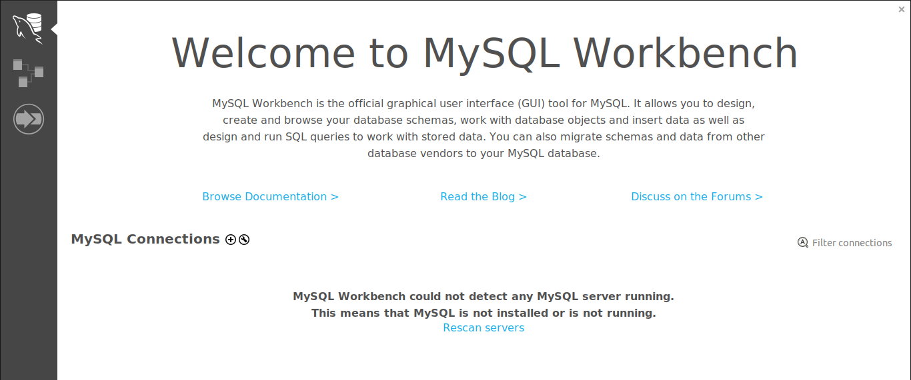

When you open mysql workbench , you will be greeted by this welcome window , to connect to database server , click on the + (plus sign ) next to MySQL connections

- Enter login credentials
Once you clicked on the add connection (+) a window will open where you will enter all your credentials necessary for you to connect to the server. It will look like this
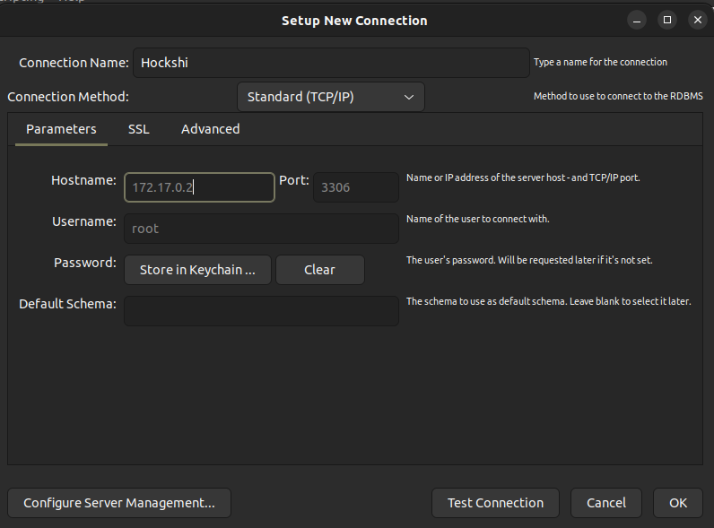

“If you do not know the ip address used by you mariadb server , execute docker inspect mariadb

And look for the IpAddress field (it is found close to the end of the result returned from the command)””

After filling in all the required information , you can click on Test connection that is found on the bottom of the window



Clicking on the Test Connection will open another window which will ask you to enter the servers password , (if you did not change the cmd found in the docker-compose.yml file the password is Password123!)
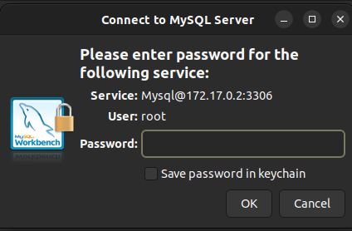

On this screen you will enter Password123! (but i highly recommend you to change this to something more secured), once this done , you can press ok and you will see the connection name on your welcome page

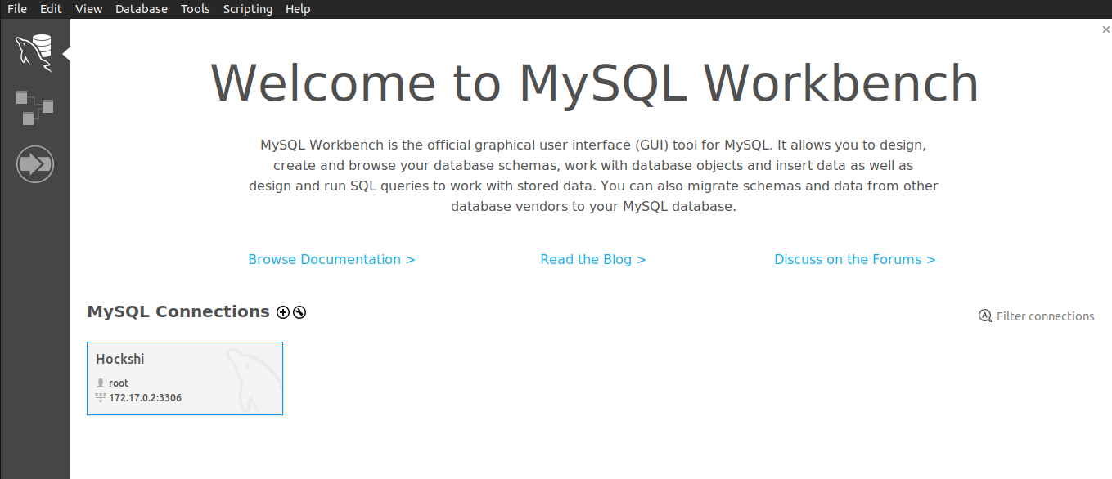

3.2 run sql commands

The next step we have to do is to populate our database with tables and data, this can be done in two different ways

1- running the commands found in database>hockshidb.sql
The hockshidb.sql file there are sql commands which you can use to create populate our database
Note: this file contains a command to create a default super_admin user

INSERT INTO powerUsers (id, email,password,role) VALUES (1, 'juniorhoza56@gmail.com','$2b$10$ksGTrtCJ4NCjqcYwar5vh.sW0lBLGlVY5TlJ8oVwVducQ13/YixcO',"super_admin");

--password = plaintextpassword

Change the email address to your email address , if this is not done , you will not be able to receive the otp code that will enable you to login

2- using sequelize-cli
In our project there are migrations which we can use to create tables in our database and we have seeders which we can use to insert data into our database

- To execute migrations, run npx sequelize-cli db:migrate –debug
- To execute seeders ,run npx sequelize-cli db:seed:all --debug

Step 4: run the application
After the pre configurations required to run our applications have been made , we can finally run our application

Execute : npm run dev

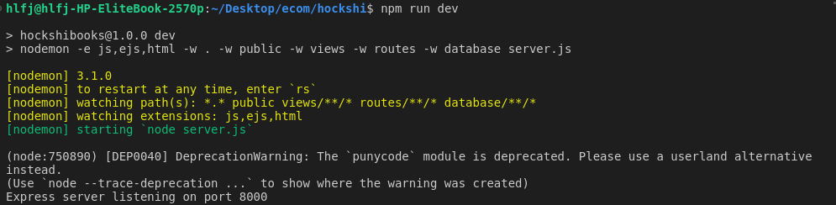

After executing the command , you should receive an output just like this

Step 5: access the application
To access the application you can enter this url in any browser of your choice
http://localhost:8000/admin/

Once you hit this endpoint , the server will respond with the login page

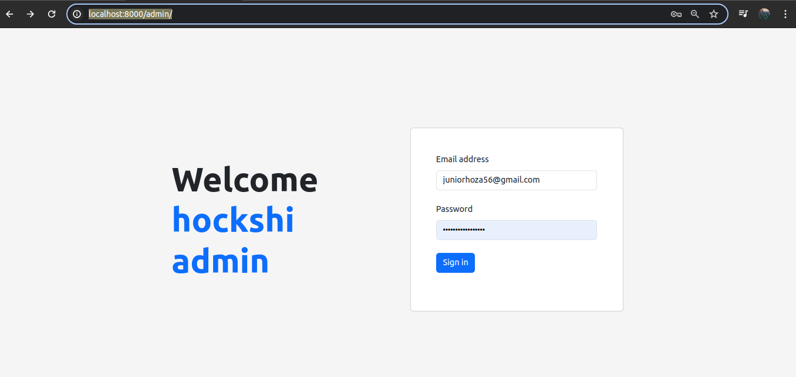

Verify that the information are correct and click on sign in,

If the informations are not correct you might receive and error just like this

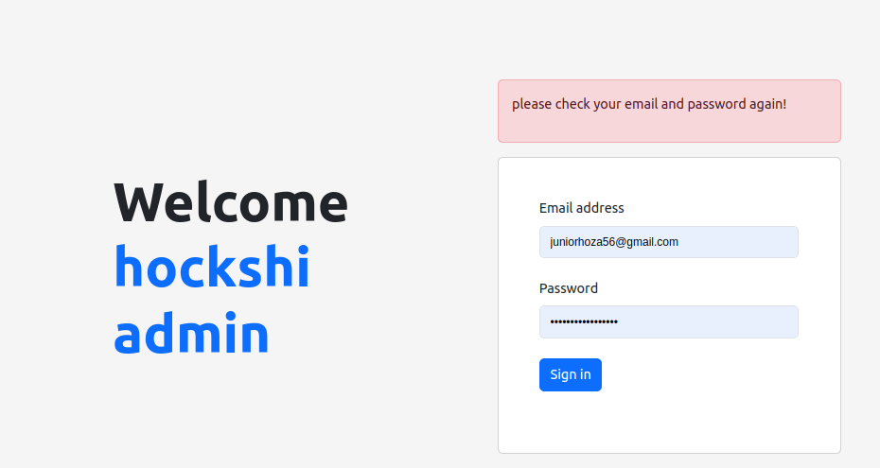

If every information is correct , you will be redirected to a second form that will ask you to enter the otp code sent to your email
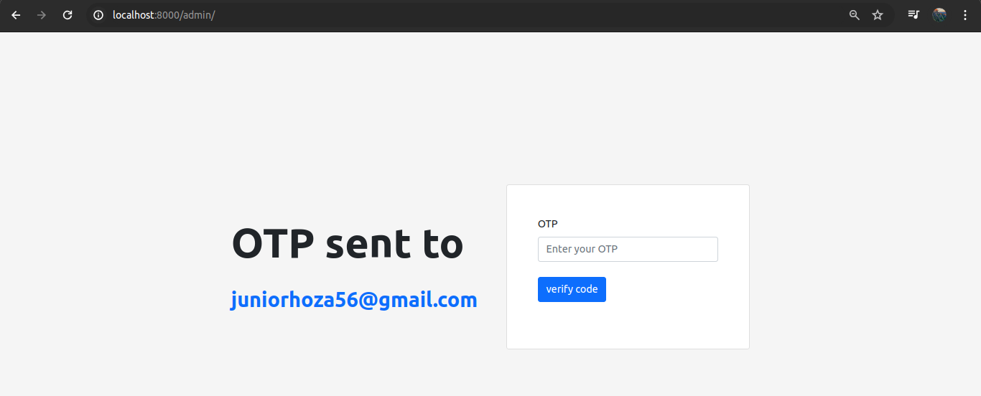

The email looks like this

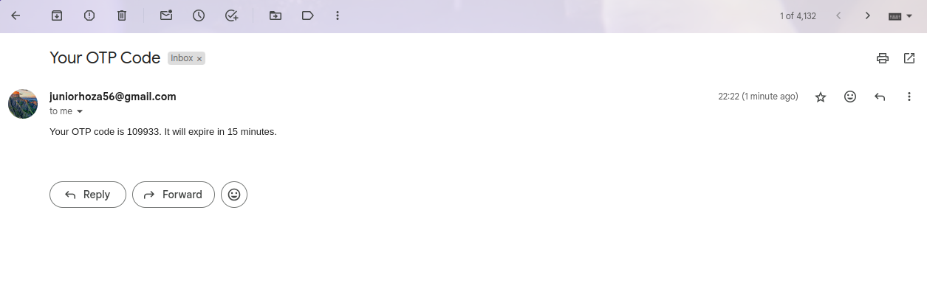
As stipulated on the email , every otp code have a life span of 15 minutes , after this time the otp code is not valid,

Copy the otp code and insert it in the verify OTP form, if the otp code is valid, you will be redirected to the dashboard

